U(V) | 0 | 2 | 4 | 6 | 8 | 10
I(mA)
U_{1K}(V)
U_{3K}(V)
table 1
graph 1

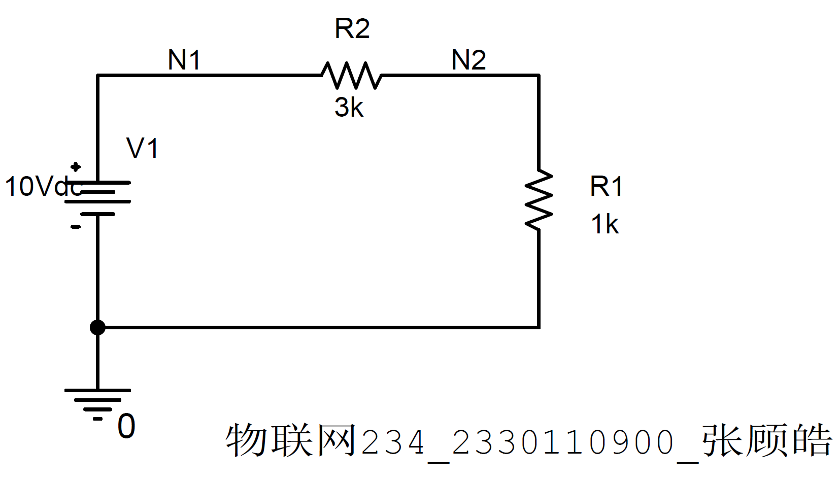
fig 1-1
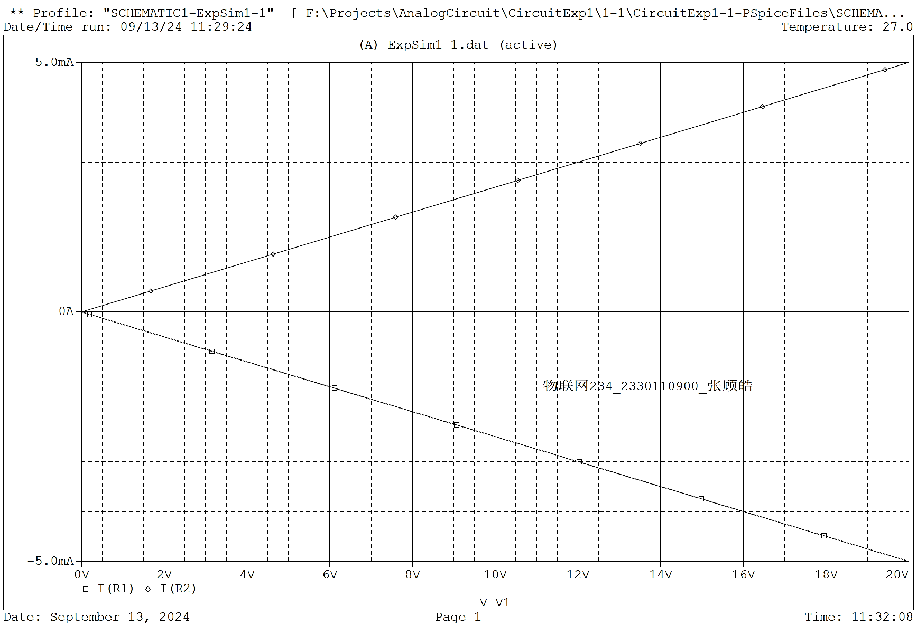
fig 1-2
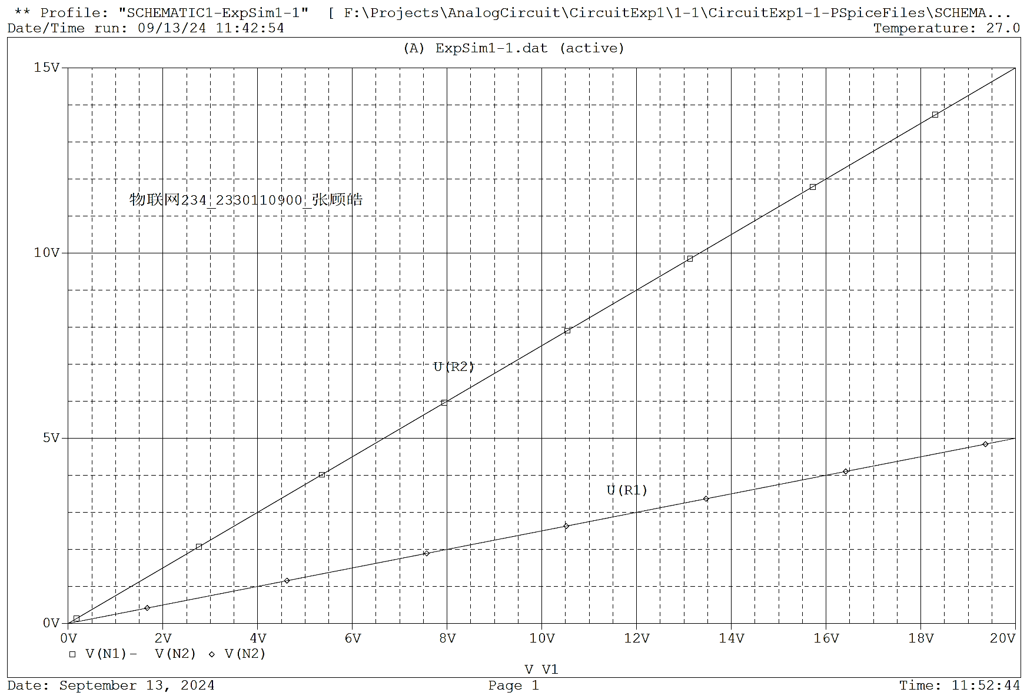
fig 1-3

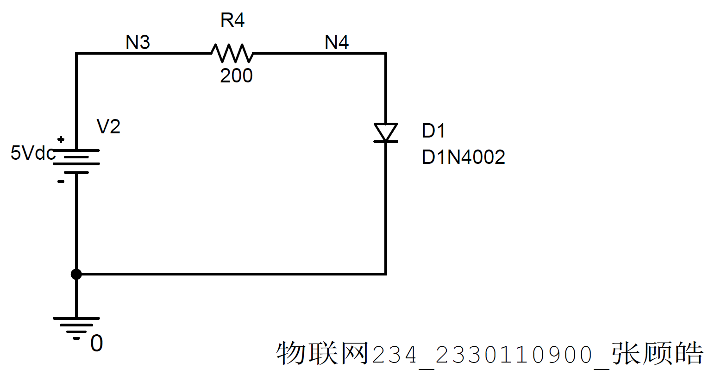
fig 2-1
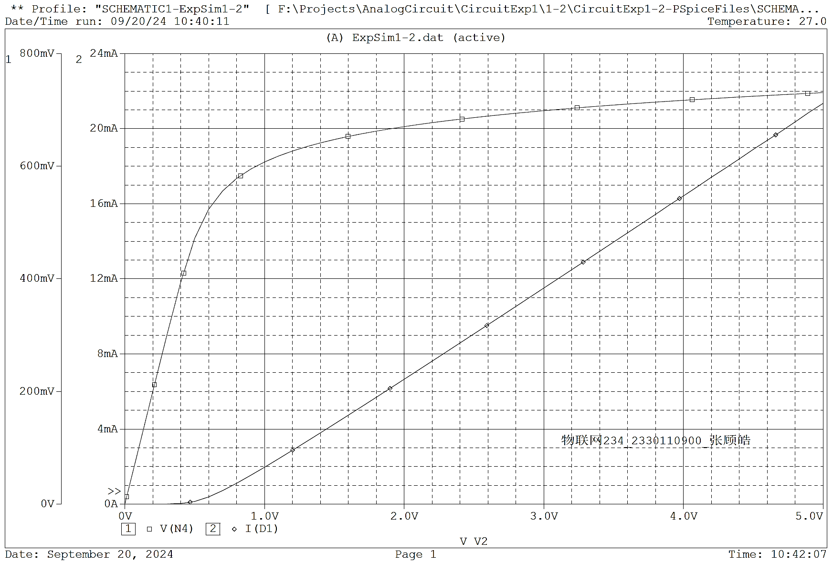
fig 2-2

