南通大学信息科学技术学院

2024-2025学年 第二学期

《Java程序设计基础》

实 验 报 告

实验名称： 实验8 综合实验

班 级：物联网234 姓 名：张顾皓 学 号：2330110900

实验日期： 2025 年 06 月 10 日

1、实验目的与要求：
【实验任务】
完成银行管理系统。

2、实验原理或程序设计思路：
2.1 系统架构描述：
层次 | 负责内容 | 关键类
表示层（UI） | 与用户交互、收集输入、展示结果 | BankSystemUI（Swing JDialog）
业务逻辑层（Core） | 账户的增删查改及业务校验 | BankSystemCore
数据持久层（JSON 文件） | 将账户列表序列化到 accounts.json 并加载 | Gson + 文件 I/O

2.2 运行流程图：
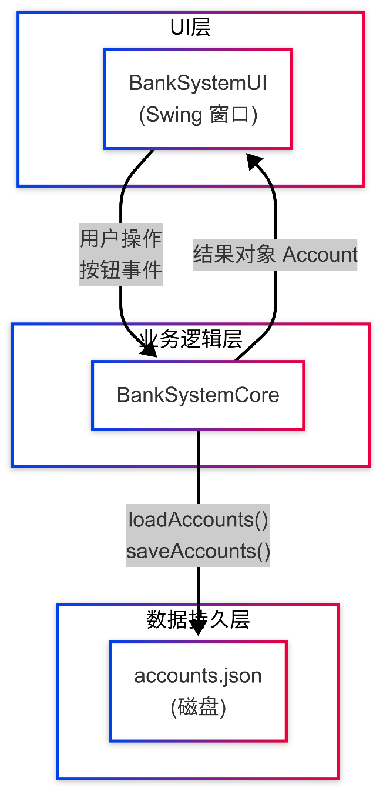

2.3 系统实现功能
- 创建账户：生成唯一 ID、初始余额 0 （CreateAccount）
- 查询账户：按 ID 返回账户信息并在界面显示
- 存款：金额 > 0；更新余额并持久化 (Deposit)
- 取款：余额检查 + 金额校验 (Withdraw)
- 转账：两账户余额原子更新 (Transfer)
- 删除账户：仅当余额为 0 时允许删除
- 异常反馈：自定义异常 AccountNotFoundException、InvalidAmountException 等，UI 弹窗友好提示

2.4 程序核心代码讲解：
方法 | 关键逻辑 | 细节
loadAccounts() | 读取 JSON → 反序列化为 List<Account> | 若文件不存在/格式错误即返回空表；保证系统可首次启动
saveAccounts() | 将账户列表写回磁盘 | 所有写操作统一走此方法，简化一致性处理
CreateAccount(name) | 校验空串→生成 ACC+timestamp → 追加保存 | 时间戳保证唯一性，避免并发冲突
Deposit/Withdraw | 金额校验→查找账户→余额运算→替换旧对象→保存 | 采用 先移除旧对象再添加新对象 的方式，避免直接引用修改导致并发读写问题
Transfer | 对两账户做余额检查→创建两个新对象→批量写回 | 一次性写磁盘保证“转入+转出”原子性
BankSystemUI | 把所有按钮事件封装为私有方法 | 事件内统一调用 Core 并用 JOptionPane 报错/提示

3、实验过程、程序运行效果截图及关键代码段：
入口文件BankSystem.java：
1. import com.formdev.flatlaf.FlatDarculaLaf;
2.
3. public class BankSystem {
4. public static void main(String[] args) {
5. FlatDarculaLaf.setup(); // 仅用于设置主题，与实际运行逻辑无关
6. javax.swing.SwingUtilities.invokeLater(() -> {
7. BankSystemUI ui = new BankSystemUI();
8. ui.pack();
9. ui.setVisible(true);
10. });
11. }
12. }

核心逻辑BankSystemCore.java：
1. import com.google.gson.Gson;
2. import com.google.gson.reflect.TypeToken;
3.
4. import java.io.FileReader;
5. import java.io.FileWriter;
6. import java.io.IOException;
7. import java.lang.reflect.Type;
8. import java.nio.file.Files;
9. import java.nio.file.Paths;
10. import java.util.ArrayList;
11. import java.util.List;
12. import java.util.Optional;
13.
14. public class BankSystemCore {
15. private final Gson gson = new Gson();
16. private static final String ACCOUNTS_FILE_PATH = "accounts.json";
17.
18. private List<Account> loadAccounts() {
19. if (!Files.exists(Paths.get(ACCOUNTS_FILE_PATH))) {
20. return new ArrayList<>();
21. }
22. try (FileReader reader = new FileReader(ACCOUNTS_FILE_PATH)) {
23. Type accountListType = new TypeToken<ArrayList<Account>>() {}.getType();
24. List<Account> accounts = gson.fromJson(reader, accountListType);
25. return accounts == null ? new ArrayList<>() : accounts;
26. } catch (IOException e) {
27. e.printStackTrace();
28. return new ArrayList<>();
29. }
30. }
31.
32. private boolean saveAccounts(List<Account> accounts) {
33. try (FileWriter writer = new FileWriter(ACCOUNTS_FILE_PATH)) {
34. gson.toJson(accounts, writer);
35. return true;
36. } catch (IOException e) {
37. e.printStackTrace();
38. return false;
39. }
40. }
41.
42. Account CreateAccount(String name) {
43. if (name == null || name.trim().isEmpty()) {
44. return null;
45. }
46. List<Account> accounts = loadAccounts();
47. String accountId = "ACC" + System.currentTimeMillis();
48. Account newAccount = new Account(accountId, name.trim(), 0.0);
49. accounts.add(newAccount);
50. if (saveAccounts(accounts)) {
51. return newAccount;
52. } else {
53. return null;
54. }
55. }
56.
57. Account QueryAccount(String accountId) throws AccountNotFoundException {
58. if (accountId == null || accountId.trim().isEmpty()) {
59. throw new AccountNotFoundException("账户ID不能为空。");
60. }
61. List<Account> accounts = loadAccounts();
62. Optional<Account> accountOpt = accounts.stream()
63. .filter(acc -> acc.getAccountId().equals(accountId.trim()))
64. .findFirst();
65. if (accountOpt.isPresent()) {
66. return accountOpt.get();
67. } else {
68. throw new AccountNotFoundException("账户 " + accountId + " 未找到。");
69. }
70. }
71.
72. void DeleteAccount(String accountId) throws AccountNotFoundException, AccountOperationException {
73. if (accountId == null || accountId.trim().isEmpty()) {
74. throw new AccountNotFoundException("账户ID不能为空。");
75. }
76. List<Account> accounts = loadAccounts();
77. Optional<Account> accountOpt = accounts.stream()
78. .filter(acc -> acc.getAccountId().equals(accountId.trim()))
79. .findFirst();
80.
81. if (accountOpt.isPresent()) {
82. Account accountToDelete = accountOpt.get();
83. if (accountToDelete.getBalance() == 0.0) {
84. accounts.remove(accountToDelete);
85. if (!saveAccounts(accounts)) {
86. throw new AccountOperationException("删除账户 " + accountId + " 时保存失败。");
87. }
88. } else {
89. throw new AccountOperationException("账户 " + accountId + " 余额不为零，无法删除。");
90. }
91. } else {
92. throw new AccountNotFoundException("要删除的账户 " + accountId + " 未找到。");
93. }
94. }
95.
96. void Deposit(String accountId, double amount) throws AccountNotFoundException, InvalidAmountException, AccountOperationException {
97. if (accountId == null || accountId.trim().isEmpty()) {
98. throw new AccountNotFoundException("账户ID不能为空。");
99. }
100. if (amount <= 0) {
101. throw new InvalidAmountException("存款金额必须为正数。");
102. }
103. List<Account> accounts = loadAccounts();
104. Optional<Account> accountOpt = accounts.stream()
105. .filter(acc -> acc.getAccountId().equals(accountId.trim()))
106. .findFirst();
107.
108. if (accountOpt.isPresent()) {
109. Account account = accountOpt.get();
110. accounts.remove(account);
111. Account updatedAccount = new Account(account.getAccountId(), account.getName(), account.getBalance() + amount);
112. accounts.add(updatedAccount);
113. if (!saveAccounts(accounts)) {
114. throw new AccountOperationException("存款到账户 " + accountId + " 时保存失败。");
115. }
116. } else {
117. throw new AccountNotFoundException("存款账户 " + accountId + " 未找到。");
118. }
119. }
120.
121. void Withdraw(String accountId, double amount) throws AccountNotFoundException, InvalidAmountException, InsufficientBalanceException, AccountOperationException {
122. if (accountId == null || accountId.trim().isEmpty()) {
123. throw new AccountNotFoundException("账户ID不能为空。");
124. }
125. if (amount <= 0) {
126. throw new InvalidAmountException("取款金额必须为正数。");
127. }
128. List<Account> accounts = loadAccounts();
129. Optional<Account> accountOpt = accounts.stream()
130. .filter(acc -> acc.getAccountId().equals(accountId.trim()))
131. .findFirst();
132.
133. if (accountOpt.isPresent()) {
134. Account account = accountOpt.get();
135. if (account.getBalance() >= amount) {
136. accounts.remove(account);
137. Account updatedAccount = new Account(account.getAccountId(), account.getName(), account.getBalance() - amount);
138. accounts.add(updatedAccount);
139. if (!saveAccounts(accounts)) {
140. throw new AccountOperationException("从账户 " + accountId + " 取款时保存失败。");
141. }
142. } else {
143. throw new InsufficientBalanceException("账户 " + accountId + " 余额不足。当前余额: " + account.getBalance() + ", 取款金额: " + amount);
144. }
145. } else {
146. throw new AccountNotFoundException("取款账户 " + accountId + " 未找到。");
147. }
148. }
149.
150. void Transfer(String fromAccountId, String toAccountId, double amount) throws AccountNotFoundException, InvalidAmountException, InsufficientBalanceException, AccountOperationException {
151. if (fromAccountId == null || fromAccountId.trim().isEmpty()) {
152. throw new AccountNotFoundException("源账户ID不能为空。");
153. }
154. if (toAccountId == null || toAccountId.trim().isEmpty()) {
155. throw new AccountNotFoundException("目标账户ID不能为空。");
156. }
157. if (fromAccountId.trim().equals(toAccountId.trim())) {
158. throw new AccountOperationException("源账户和目标账户不能相同。");
159. }
160. if (amount <= 0) {
161. throw new InvalidAmountException("转账金额必须为正数。");
162. }
163.
164. List<Account> accounts = loadAccounts();
165. Account fromAccount = accounts.stream()
166. .filter(acc -> acc.getAccountId().equals(fromAccountId.trim()))
167. .findFirst()
168. .orElseThrow(() -> new AccountNotFoundException("源账户 " + fromAccountId + " 未找到。"));
169.
170. Account toAccount = accounts.stream()
171. .filter(acc -> acc.getAccountId().equals(toAccountId.trim()))
172. .findFirst()
173. .orElseThrow(() -> new AccountNotFoundException("目标账户 " + toAccountId + " 未找到。"));
174.
175. if (fromAccount.getBalance() >= amount) {
176. accounts.remove(fromAccount);
177. accounts.remove(toAccount);
178.
179. Account updatedFromAccount = new Account(fromAccount.getAccountId(), fromAccount.getName(), fromAccount.getBalance() - amount);
180. Account updatedToAccount = new Account(toAccount.getAccountId(), toAccount.getName(), toAccount.getBalance() + amount);
181.
182. accounts.add(updatedFromAccount);
183. accounts.add(updatedToAccount);
184.
185. if (!saveAccounts(accounts)) {
186. throw new AccountOperationException("转账时保存账户信息失败。");
187. }
188. } else {
189. throw new InsufficientBalanceException("源账户 " + fromAccountId + " 余额不足。当前余额: " + fromAccount.getBalance() + ", 转账金额: " + amount);
190. }
191. }
192. }
193.
194. // Custom Exception Classes
195. class AccountNotFoundException extends Exception {
196. public AccountNotFoundException(String message) {
197. super(message);
198. }
199. }
200.
201. class InsufficientBalanceException extends Exception {
202. public InsufficientBalanceException(String message) {
203. super(message);
204. }
205. }
206.
207. class InvalidAmountException extends Exception {
208. public InvalidAmountException(String message) {
209. super(message);
210. }
211. }
212.
213. class AccountOperationException extends Exception {
214. public AccountOperationException(String message) {
215. super(message);
216. }
217. }
218.
219. class Account {
220. private String accountId;
221. private String name;
222. private double balance;
223.
224. public Account(String accountId, String name, double balance) {
225. this.accountId = accountId;
226. this.name = name;
227. this.balance = balance;
228. }
229.
230. public String getAccountId() {
231. return accountId;
232. }
233.
234. public String getName() {
235. return name;
236. }
237.
238. public double getBalance() {
239. return balance;
240. }
241. }
242.

UI界面文件BankSystemUI.java：
1. import javax.swing.*;
2.
3. public class BankSystemUI extends JDialog {
4. private JTextField accountIdField;
5. private JButton QueryButton, CreateButton, DepositButton, WithdrawButton, TransferButton, DeleteButton;
6. private JTextField NameField, BalanceField;
7. private JPanel contentPane;
8.
9. private BankSystemCore core = new BankSystemCore();
10.
11. public BankSystemUI() {
12. setResizable(false);
13. setContentPane(contentPane);
14. setDefaultCloseOperation(DISPOSE_ON_CLOSE);
15. setTitle("简易银行系统");
16.
17. QueryButton.addActionListener(e -> queryAccountAction());
18.
19. CreateButton.addActionListener(e -> {
20. String name = JOptionPane.showInputDialog(this, "请输入账户名:", "创建账户", JOptionPane.PLAIN_MESSAGE);
21. if (name == null || name.trim().isEmpty()) {
22. if (name != null) {
23. JOptionPane.showMessageDialog(this, "账户名不能为空。", "创建账户错误", JOptionPane.ERROR_MESSAGE);
24. }
25. return;
26. }
27. try {
28. Account account = core.CreateAccount(name.trim());
29. if (account != null) {
30. JOptionPane.showMessageDialog(this, "账户创建成功！\n账户ID: " + account.getAccountId(), "创建账户成功", JOptionPane.INFORMATION_MESSAGE);
31. accountIdField.setText(account.getAccountId());
32. queryAccountAction();
33. } else {
34. JOptionPane.showMessageDialog(this, "创建账户失败。", "创建账户错误", JOptionPane.ERROR_MESSAGE);
35. }
36. } catch (Exception ex) {
37. JOptionPane.showMessageDialog(this, "创建账户时发生错误: " + ex.getMessage(), "创建账户错误", JOptionPane.ERROR_MESSAGE);
38. }
39. });
40.
41. DepositButton.addActionListener(e -> {
42. String id = accountIdField.getText().trim();
43. if (id.isEmpty()) {
44. JOptionPane.showMessageDialog(this, "请输入账户ID。", "存款错误", JOptionPane.ERROR_MESSAGE);
45. return;
46. }
47. String amt = JOptionPane.showInputDialog(this, "请输入存款金额:", "存款", JOptionPane.PLAIN_MESSAGE);
48. if (amt == null || amt.trim().isEmpty()) return;
49. try {
50. core.Deposit(id, Double.parseDouble(amt.trim()));
51. JOptionPane.showMessageDialog(this, "存款成功。", "存款成功", JOptionPane.INFORMATION_MESSAGE);
52. queryAccountAction();
53. } catch (NumberFormatException ex) {
54. JOptionPane.showMessageDialog(this, "无效的金额格式。", "存款错误", JOptionPane.ERROR_MESSAGE);
55. } catch (Exception ex) {
56. JOptionPane.showMessageDialog(this, ex.getMessage(), "存款错误", JOptionPane.ERROR_MESSAGE);
57. }
58. });
59.
60. WithdrawButton.addActionListener(e -> {
61. String id = accountIdField.getText().trim();
62. if (id.isEmpty()) {
63. JOptionPane.showMessageDialog(this, "请输入账户ID。", "取款错误", JOptionPane.ERROR_MESSAGE);
64. return;
65. }
66. String amt = JOptionPane.showInputDialog(this, "请输入取款金额:", "取款", JOptionPane.PLAIN_MESSAGE);
67. if (amt == null || amt.trim().isEmpty()) return;
68. try {
69. core.Withdraw(id, Double.parseDouble(amt.trim()));
70. JOptionPane.showMessageDialog(this, "取款成功。", "取款成功", JOptionPane.INFORMATION_MESSAGE);
71. queryAccountAction();
72. } catch (NumberFormatException ex) {
73. JOptionPane.showMessageDialog(this, "无效的金额格式。", "取款错误", JOptionPane.ERROR_MESSAGE);
74. } catch (Exception ex) {
75. JOptionPane.showMessageDialog(this, ex.getMessage(), "取款错误", JOptionPane.ERROR_MESSAGE);
76. }
77. });
78.
79. TransferButton.addActionListener(e -> {
80. String from = accountIdField.getText().trim();
81. if (from.isEmpty()) {
82. JOptionPane.showMessageDialog(this, "请输入源账户ID。", "转账错误", JOptionPane.ERROR_MESSAGE);
83. return;
84. }
85. String to = JOptionPane.showInputDialog(this, "请输入目标账户ID:", "转账", JOptionPane.PLAIN_MESSAGE);
86. if (to == null || to.trim().isEmpty()) return;
87. String amt = JOptionPane.showInputDialog(this, "请输入转账金额:", "转账", JOptionPane.PLAIN_MESSAGE);
88. if (amt == null || amt.trim().isEmpty()) return;
89. try {
90. core.Transfer(from, to.trim(), Double.parseDouble(amt.trim()));
91. JOptionPane.showMessageDialog(this, "转账成功。", "转账成功", JOptionPane.INFORMATION_MESSAGE);
92. queryAccountAction();
93. } catch (NumberFormatException ex) {
94. JOptionPane.showMessageDialog(this, "无效的金额格式。", "转账错误", JOptionPane.ERROR_MESSAGE);
95. } catch (Exception ex) {
96. JOptionPane.showMessageDialog(this, ex.getMessage(), "转账错误", JOptionPane.ERROR_MESSAGE);
97. }
98. });
99.
100. DeleteButton.addActionListener(e -> {
101. String id = accountIdField.getText().trim();
102. if (id.isEmpty()) {
103. JOptionPane.showMessageDialog(this, "请输入要删除的账户ID。", "删除错误", JOptionPane.ERROR_MESSAGE);
104. return;
105. }
106. int res = JOptionPane.showConfirmDialog(this, "确认删除账户 " + id + "？", "删除确认", JOptionPane.YES_NO_OPTION, JOptionPane.WARNING_MESSAGE);
107. if (res == JOptionPane.YES_OPTION) {
108. try {
109. core.DeleteAccount(id);
110. JOptionPane.showMessageDialog(this, "删除成功。", "删除成功", JOptionPane.INFORMATION_MESSAGE);
111. accountIdField.setText("");
112. clearFields();
113. } catch (Exception ex) {
114. JOptionPane.showMessageDialog(this, ex.getMessage(), "删除错误", JOptionPane.ERROR_MESSAGE);
115. }
116. }
117. });
118. }
119.
120. private void queryAccountAction() {
121. String id = accountIdField.getText().trim();
122. if (id.isEmpty()) {
123. JOptionPane.showMessageDialog(this, "账户ID不能为空。", "查询错误", JOptionPane.ERROR_MESSAGE);
124. clearFields();
125. return;
126. }
127. try {
128. Account acc = core.QueryAccount(id);
129. NameField.setText(acc.getName());
130. BalanceField.setText(String.format("%.2f", acc.getBalance()));
131. } catch (Exception ex) {
132. JOptionPane.showMessageDialog(this, ex.getMessage(), "查询错误", JOptionPane.ERROR_MESSAGE);
133. clearFields();
134. }
135. }
136.
137. private void clearFields() {
138. NameField.setText("");
139. BalanceField.setText("");
140. }
141.
142. }

UI设计BankSystemUI.form示意图：
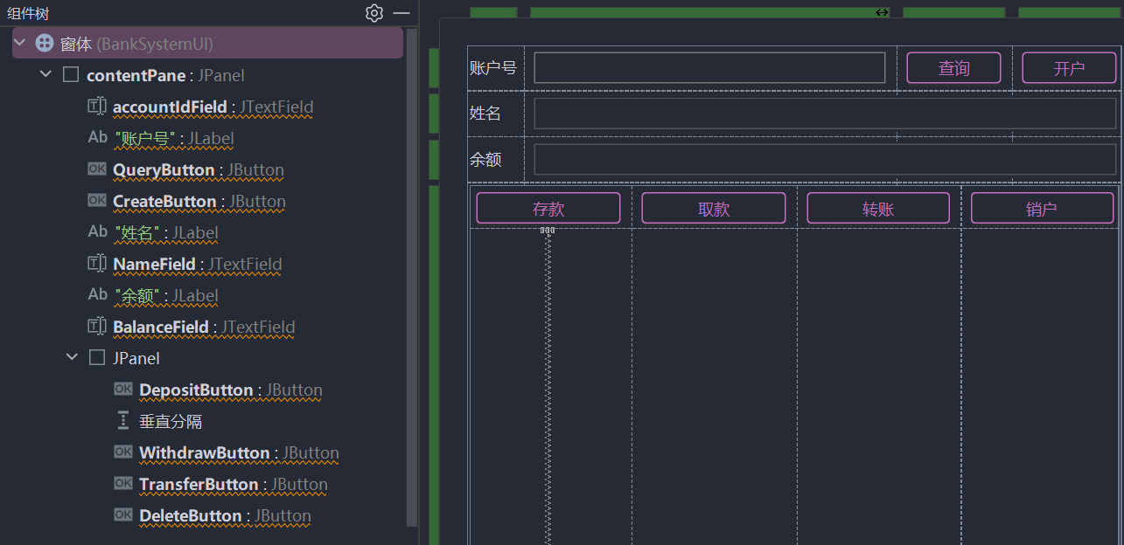

运行结果：
运行程序，显示主窗口
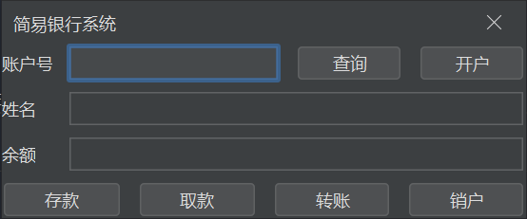
点击开户，输入姓名，自动生成账户号并自动填写
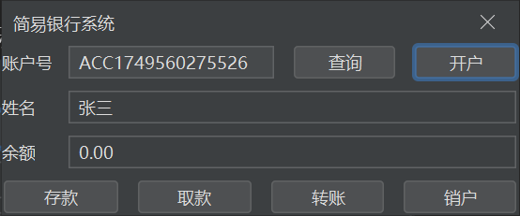
执行存款操作，存入50元，操作正常
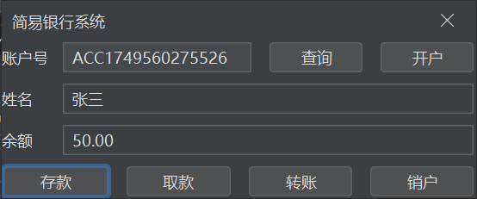
执行存款操作，尝试存入-100元，由于输入值无效报错
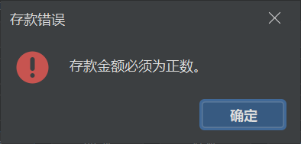
执行取款操作，尝试取出60元，此时由于余额不足，取款失败
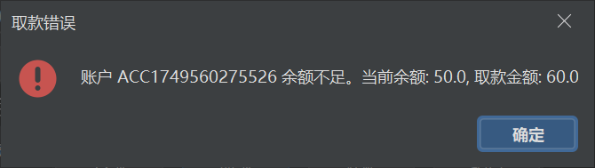
尝试取出30元，余额充足，取款成功
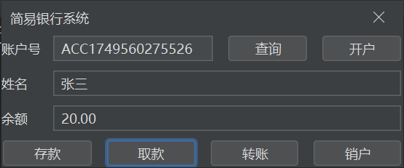
尝试给不存在的账户转账，转账失败
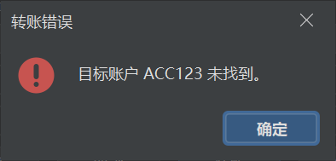
新建一个账户，向其转入10元，成功
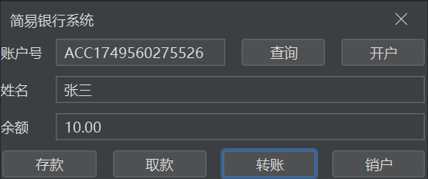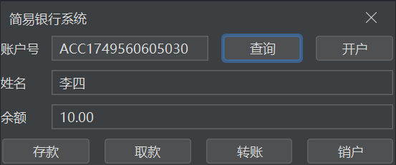
尝试删除新建的账户，因为仍有余额，无法删除
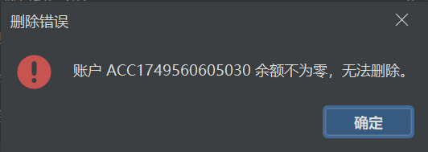
使用取款操作使余额置零后再次尝试销户，删除成功，现无法查询到账户
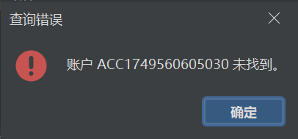
数据确定以json格式持久化保存（为显示方便，已预先格式化文件处理）
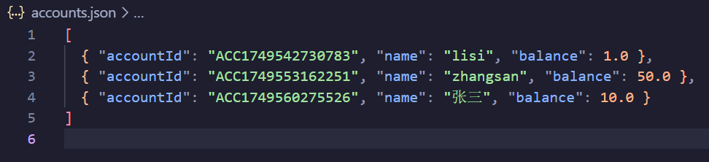
结论：已实现的程序逻辑正常。

4、实验过程中遇到的问题及解决方法：
问题/易错点 | 现有或推荐解决策略
并发写文件导致数据丢失 | 采用单线程 Swing 应用 + 每次操作完即写盘；若需并发可引入文件锁或改用数据库
金额非法或余额不足 | 业务层抛出自定义异常；UI 捕获后弹窗提示，避免程序崩溃
删除含余额账户 | 业务层显式检查 balance==0 后才允许删除
ID 输入为空/格式错误 | UI 层先行校验，减少无效 Core 调用
数据文件损坏 | loadAccounts() 捕获 IOException，返回空表并在控制台打印错误，保证系统仍可启动

5、实验心得体会：
本实验采用了以下编程技巧，使得整体简单又易扩展：
- 分层思想：UI 与业务逻辑彻底解耦，使后续可进一步修改前端而无需大量重写核心代码。
- 数据持久化简化实现：通过 Gson 将对象列表序列化为 JSON，降低了引入数据库的额外成本
- 异常与提示友好：自定义异常+Swing 弹窗让错误信息直观易懂
该系统简单的同时实现了基础功能，且在非复杂生产环境下可用不会出现意外错误。

